What's a Variable?
A variable is a representation of a particular value, such as blue or 19349377. By assigning a value to a variable, you can reference the variable in other places in your script, and that value will always remain the same (unless you change it, which you'll learn about later).
To create a variable, do the following (in your head):
- Think of a good name! For instance, if I want to create a variable to hold a username, I name my variable:
username
- Put a dollar sign ($) in front of that name:
$username
- Use the equals sign after the name (=) to assign a literal value to that variable. Put the value in quotation marks:
$username = "joe"
- Assigning a value to a variable is an instruction and as such should be terminated with a semicolon:
$username = "joe";
Naming Your Variables
As you've seen, variables begin with a dollar sign ($) and are followed by a meaningful name. The variable name cannot begin with a numeric character, but it can contain numbers and the underscore character (_). Additionally, variable names are case sensitive, meaning that $YOURVAR and $yourvar are two different variables.
PHP Variable and Value Types
You will create two main types of variables in your PHP code: scalar and array. Scalar variables contain only one value at a time, and arrays contain a list of values or even another array.
When you assign a value to a variable, you usually assign a value of one of the following types:
- Integers. Whole numbers (numbers without decimals). Examples are 1, 345, and 9922786. You can also use octal and hexadecimal notation: The octal 0123 is decimal 83 and the hexadecimal 0x12 is decimal 18.

NEW! 64-BIT INTEGERS

- Floating-point numbers ("floats" or "doubles"). Numbers with decimals. Examples are 1.5, 87.3446, and 0.88889992.
- Strings. Text or numeric information, specified within double quotes (" ") or single quotes (' ').
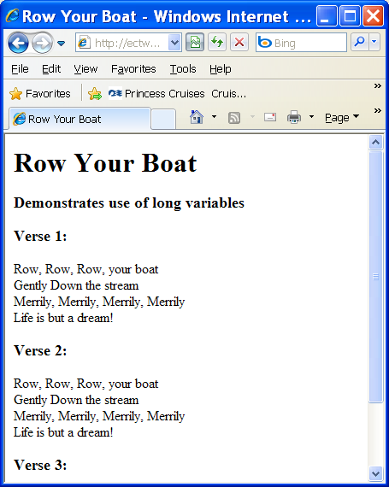 | Basics/multiplelinestring.php  <html>  <head>  <title>Row Your Boat</title>  </head>  <body>  <h1>Row Your Boat</h1>  <h3>Demonstrates use of long variables</h3>  <?php  $verse = <<<HERE  <p>  Row, Row, Row, your boat<br />  Gently Down the stream<br />  Merrily, Merrily, Merrily, Merrily<br />  Life is but a dream!<br />  </p>  HERE;  print "<h3>Verse 1:</h3>";  print $verse;  print "<h3>Verse 2:</h3>";  print $verse;  print "<h3>Verse 3:</h3>";  print $verse;  ?>  </body>  </html>

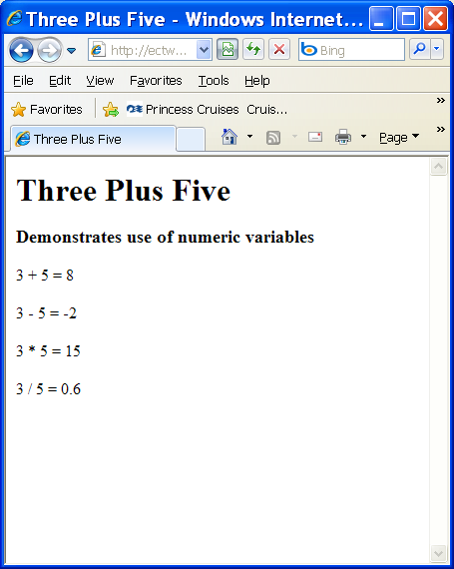 | Basics/numbers.php  <html>  <head>  <title>Three Plus Five</title>  </head>  <body>  <h1>Three Plus Five</h1>  <h3>Demonstrates use of numeric variables</h3>  <?php  $x = 3;  $y = 5;  $sum = $x + $y;  $dif = $x - $y;  $prod = $x * $y;  $quotient = $x / $y;  print <<< HERE  <p>$x + $y = $sum</p>  <p>$x - $y = $dif</p>  <p>$x * $y = $prod</p>  <p>$x / $y = $quotient</p>  HERE;  ?>  </body>  </html>

Predefined Variables
In all PHP scripts, a set of predefined variables is available to you. Some of these predefined variables are called superglobals, meaning that they are always present and available to all of your scripts, without any intervention by you, the programmer.

$_GET contains any variables provided to a script through the GET method.
$_POST contains any variables provided to a script through the POST method.
$_COOKIE contains any variables provided to a script through a cookie.
$_FILES contains any variables provided to a script through file uploads.
$_ENV contains any variables provided to a script as part of the server environment.
$_SESSION contains any variables that are registered in a session.

Using Constants
A constant is an identifier for a value that cannot change during the course of a script. Once a constant has a value, it remains through its execution lifetime. Constants can be user defined, or you can use some of the predefined constants that PHP always has available. Unlike simple variables, constants do not have a dollar sign before their name, and they are usually uppercase to show their difference from a scalar variable.
Example:
define("MYCONSTANT", "This is a test of defining constants.");
Some predefined constants include:
__FILE__: The name of the script file being parsed.
__LINE__: The number of the line in the script being parsed.
PHP_VERSION: The version of PHP in use.
PHP_OS: The operating system using PHP.

What's an Operator?
The basic function of an operator is to do something with the value of a variable. That "something" can be to assign a value, change a value, or compare two or more values.
Here are the main types of PHP operators:
- Assignment operators. Assign values to variables. Can also add to or subtract from a variable's current value.
- Arithmetic operators. Addition, subtraction, division, and multiplication occur when these operators are used.
- Comparison operators. Compare two values and return either true or false. You can then perform actions based on the returned value.
- Logical operators. Determine the status of conditions.

Assignment Operators:
Operator | Example | Action
+= | $a += 3; | Changes the value of a variable to the current value plus the value on the right side.
-= | $a -= 3; | Changes the value of a variable to the current value minus the value on the right side.
.= | $a .= "string"; | Concatenates (adds on to) the value on the right side with the current value.

Arithmetic Operators:
Operator | Example | Action
+ | $b = $a + 3; | Adds values
- | $b = $a - 3; | Subtracts values
* | $b = $a * 3; | Multiplies values
/ | $b = $a / 3; | Divides values
% | $b = $a % 3; | Returns the modulus, or remainder

Comparison Operators:
Operator | Definition
== | Equal to
!= | Not equal to
> | Greater than
< | Less than
>= | Greater than or equal to
<= | Less than or equal to

Logical Operators: && (and) and || (or)
Building an HTML Page with a Form

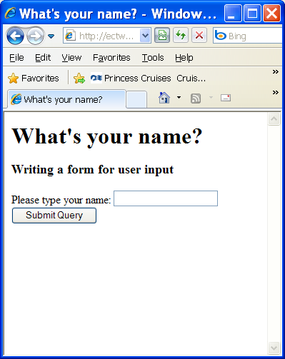  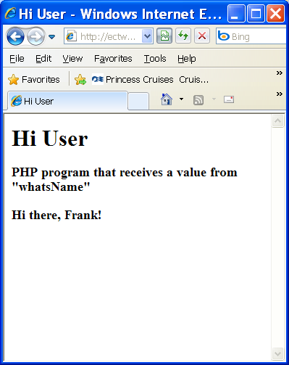 | Basics/whatsname.html  <html>  <head>  <title>What's your name?</title>  </head>  <body>  <p><h1>What's your name?</h1></p>  <h3>Writing a form for user input</h3>  <p><form method = "get"action = "hiUser.php">  Please type your name:  <input type = "text" name="userName">  <input type = "submit" >  </form></p>  </body>  </html>  Basics/hiUser.php  <html>  <head>  <title>Hi User</title>  </head>  <body>  <h1>Hi User</h1>  <h3>PHP program that receives a value from "whatsName"</h3>  <?php  $userName = filter_input(INPUT_GET, "userName");  print "<h3>Hi there, $userName!</h3>";  ?>  </body>  </html>

HTML forms contain at least the following elements:
- A method: this attribute indicates how the data is sent to the browser. Get and post are the two primary methods.
- An action: It determines the URL of a program, designed to read the page and respond with another page. The URL can be an absolute reference (which begins with http:// and contains the entire domain name of the response program), or a relative reference (meaning the program is in the same directory as the original web page). When possible, I prefer relative references because they are cleaner and easier to manage.
- A submit button

Working with an Array
Simple Functions for Inspecting Arrays
Function | Behavior
is_array() | Takes a single argument of any type and returns a true value if the argument is an array, and false otherwise.
count() | Takes an array as argument and returns the number of nonempty elements in the array. (This will be 1 for strings and numbers.)
sizeof() | Identical to count().
in_array() | Takes two arguments: an element (that might be a value in an array), and an array (that might contain the element). Returns true if the element is contained as a value in the array, false otherwise. (Note that this does not test for the presence of keys in the array.)
isset($array[$key]) | Takes an array[key] form and returns true if the key portion is a valid key for the array. (This is a specific use of the more general function isset(), which tests whether a variable is bound.)

Iteration functions:
Our favorite construct for looping through an array is foreach. Although it is probably inherited from Perl's foreach, it has a somewhat odd syntax (which is not the same as Perl's odd syntax). It comes in two flavors—which one you decide to use will depend on whether you care about the array's keys or just the values.
foreach ($array_variable as $value_variable) {
// .. do something with the value in $value_variable
} // Note that this is an example template, not real PHP code

foreach ($array_variable as $key_var => $value_var) {
// .. do something with $key_var and/or $value_var
}
Although in the preceding pseudocode we assume that the array of interest is in the variable $array_variable, you can have any expression that evaluates to an array in that position, for example:
foreach (function_returning_array() as $value_variable) {
// .. do something with the value in $value_variable
}

Functions for Iterating over arrays

Function | Arguments | Side Effect | Return Value
current() | One array argument | None. | The value from the key/value pair currently pointed to by the internal "current" pointer (or false if no such value).
next() | One array argument | Advances the pointer by one. If already at the last element, it will move the pointer "past the end,"and subsequent calls to current() will return false. | The value pointed to after the pointer has been advanced (or false if no such value).
prev() | One array argument | Moves the pointer back by one. If already at the first element, will move the pointer "before the beginning." | The value pointed to after the pointer has been moved back (or false if no such value).
reset() | One array argument | Moves the pointer back to point to the first key/value pair, or "before the beginning" if the array is empty. | The first value stored in the array, or false for an empty array.
end() | One array argument | Moves the pointer ahead to the last key/value pair. | The last value that is currently in the list of key/value pairs.
pos() | One array argument | None. (This function is an alias for current().) | The value of the key/value pair that is currently pointed to.
each() | One array argument | Moves the pointer ahead to the next key/value pair. | An array that packages the keys and values of the key/value pair that was current before the pointer was moved (or false if no such pair). The returned array stores the

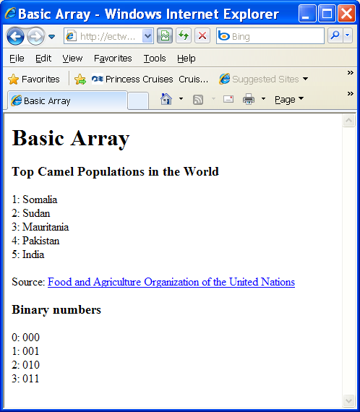 | Basics/basicarray.php  <html>  <head>  <title>  Basic Array  </title>  </head>  <body>  <h1>Basic Array</h1>  <?php  //simply assign values to array  $camelPop[1] = "Somalia";  $camelPop[2] = "Sudan";  $camelPop[3] = "Mauritania";  $camelPop[4] = "Pakistan";  $camelPop[5] = "India";  //output array values  print "<h3>Top Camel Populations in the World</h3>\n";  print "<p> \n";  for ($i = 1; $i <= 5; $i++){  print "$i: $camelPop[$i]<br />\n";  } // end for loop  print "</p> \n";  print <<< HERE  <p style = "text-decoration: italic">  Source:  <a href = "http://www.fao.org/ag/aga/glipha/index.jsp">  Food and Agriculture Organization of the United Nations</a>  </p>  HERE;  //use array function to load up array  $binary = array("000", "001", "010", "011");  print "<h3>Binary numbers</h3>\n";  print "<p> \n";  for ($i = 0; $i < count($binary); $i++){  print "$i: $binary[$i]<br />\n";  } // end for loop  print "</p> \n";  ?>  </body>  </html>

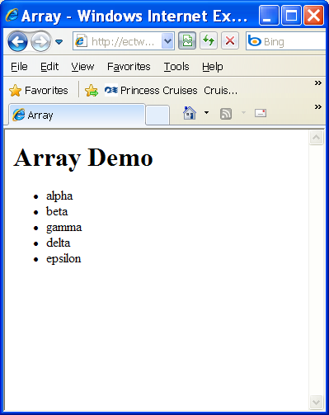 | Basics/array.php  <html>  <head>  <title>Array</title>  </head>  <body>  <h1>Array Demo</h1>  <?php  $list = array("alpha", "beta", "gamma", "delta", "epsilon");  print "<ul>\n";  foreach ($list as $value){  print " <li>$value</li>\n";  } // end foreach  print "</ul>\n";  ?>  </body>  </html>

Creating an Associative Array
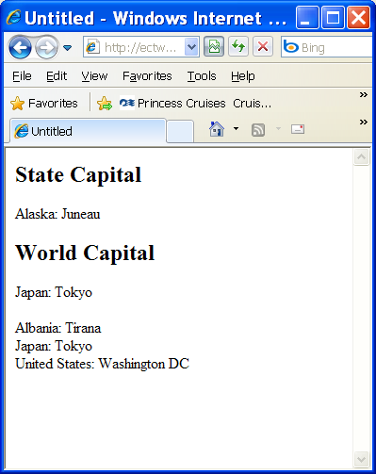 | Basics/associativearrays.php  <html>  <head>  <title>Untitled</title>  </head>  <body>  <?php  $stateCap["Alaska"] = "Juneau";  $stateCap["Indiana"] = "Indianapolis";  $stateCap["Michigan"] = "Lansing";  $cap = $stateCap["Alaska"];  print <<<HERE  <h2>State Capital</h2>  Alaska: $cap<br>  HERE;  $worldCap = array(  "Albania"=>"Tirana",  "Japan"=>"Tokyo",  "United States"=>"Washington DC"  );  $cap = $worldCap["Japan"];  print <<<HERE  <h2>World Capital</h2>  Japan: $cap<br>  </dl>  HERE;  foreach ($worldCap as $country => $capital){  print "$country: $capital<br>\n";} // end foreach  ?>  </body>  </html>

Creating a Multidimensional Array
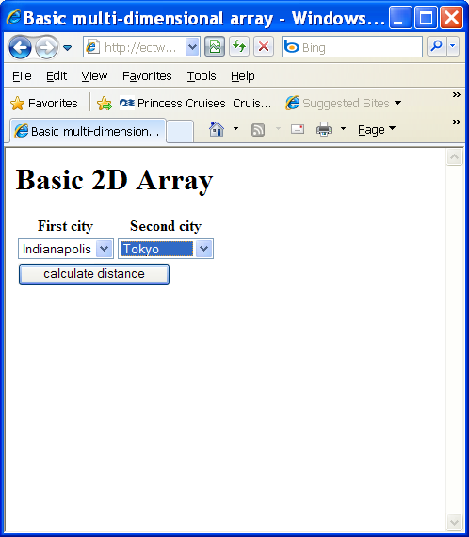  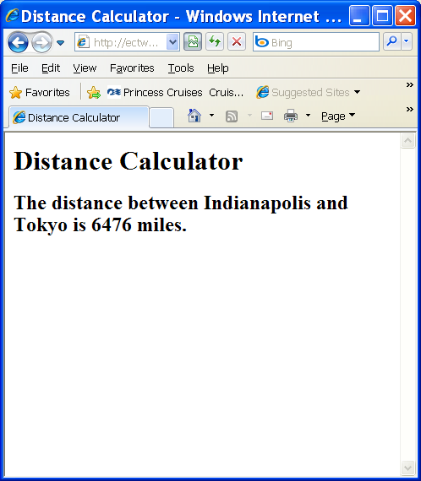 | Basics/basicMultiArray.html  <html>  <head>  <title>Basic multi-dimensional array</title>  </head>  <body>  <h1>Basic 2D Array</h1>  <form action = "basicMultiArray.php"  method = "post">  <table>  <tr>  <th>First city</th>  <th>Second city</th>  </tr>  <!-- note each option value is numeric -->  <tr>  <td>  <select name = "cityA">  <option value = "0">Indianapolis</option>  <option value = "1">New York</option>  <option value = "2">Tokyo</option>  <option value = "3">London</option>  </select>  </td>  <td>  <select name = "cityB">  <option value = "0">Indianapolis</option>  <option value = "1">New York</option>  <option value = "2">Tokyo</option>  <option value = "3">London</option>  </select>  </td>  </tr>  <tr>  <td colspan = "2">  <input type = "submit"  value = "calculate distance" />  </td>  </tr>  </table>  </form>  </body>  </html>  Basics/basicMultiArray.php  <html>  <head>  <title>Distance Calculator</title>  </head>  <body>  <h1>Distance Calculator</h1>  <?php  $cityName = array("Indianapolis", "New York", "Tokyo", "London");  $distance = array(  array(0, 648, 6476, 4000),  array(648, 0, 6760, 3470),  array(6476, 6760, 0, 5956),  array(4000, 3470, 5956, 0)  );  $cityA = filter_input(INPUT_POST, "cityA");  $cityB = filter_input(INPUT_POST, "cityB");  $fromCity = $cityName[$cityA];  $toCity = $cityName[$cityB];  $result = $distance[$cityA][$cityB];  print "<h2>The distance between $fromCity and $toCity is $result miles.</h2>  \n";  ?>  </body>  </html>

Making a Two-Dimensional Associative Array
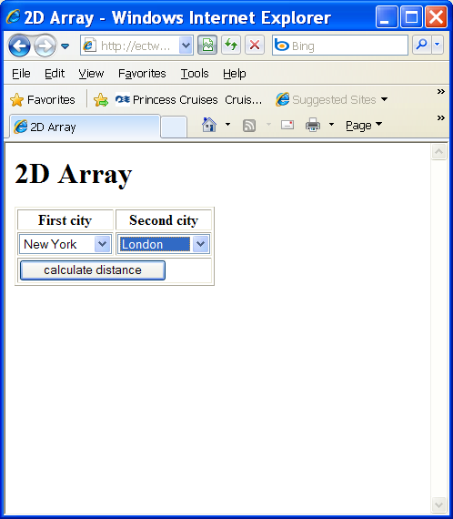  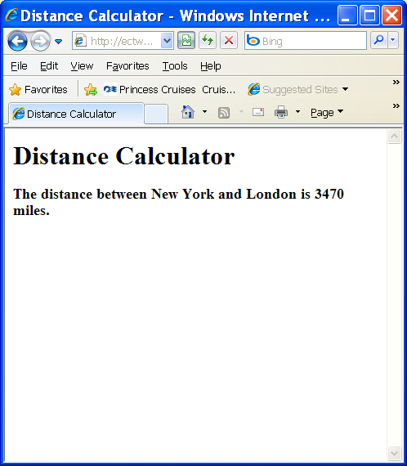 | Basics/MultiArray.html  <html>  <head>  <title>2D Array</title>  </head>  <body>  <h1>2D Array</h1>  <form action = "multiArray.php"  method = "post">  <table border = "1">  <tr>  <th>First city</th>  <th>Second city</th>  </tr>  <!-- note each option value is a string -->  <tr>  <td>  <select name = "cityA">  <option value = "Indianapolis">Indianapolis</option>  <option value = "New York">New York</option>  <option value = "Tokyo">Tokyo</option>  <option value = "London">London</option>  </select>  </td>  <td>  <select name = "cityB">  <option value = "Indianapolis">Indianapolis</option>  <option value = "New York">New York</option>  <option value = "Tokyo">Tokyo</option>  <option value = "London">London</option>  </select>  </td>  </tr>  <tr>  <td colspan = "2">  <input type = "submit"  value = "calculate distance" />  </td>  </tr>  </table>  </form>  </body>  </html>  Basics/multiArray.php  <html>  <head>  <title>Distance Calculator</title>  </head>  <body>  <h1>Distance Calculator</h1>  <?php  //create arrays  $indy = array (  "Indianapolis" => 0,  "New York" => 648,  "Tokyo" => 6476,  "London" => 4000  );  $ny = array (  "Indianapolis" =>648,  "New York" => 0,  "Tokyo" => 6760,  "London" => 3470  );  $tokyo = array (  "Indianapolis" => 6476,  "New York" => 6760,  "Tokyo" => 0,  "London" => 5956  );  $london = array (  "Indianapolis" => 4000,  "New York" => 3470,  "Tokyo" => 5956,  "London" => 0  );  //set up master array  $distance = array (  "Indianapolis" => $indy,  "New York" => $ny,  "Tokyo" => $tokyo,  "London" => $london  );  $cityA = filter_input(INPUT_POST, "cityA");  $cityB = filter_input(INPUT_POST, "cityB");  $result = $distance[$cityA][$cityB];  print "<h3>The distance between $cityA and $cityB is $result miles.</h3>";  ?>  </body>  </html>

Manipulating String Values
Singly Quoted Strings
Except for a couple of specially interpreted character sequences, singly quoted strings read in and store their characters literally.

Doubly Quoted Strings
Strings that are delimited by double quotes (as in "this") are preprocessed in both the following two ways by PHP:

- Certain character sequences beginning with backslash (\) are replaced with special characters.
- Variable names (starting with $) are replaced with string representations of their values.
Difference between echo and print
The command print is very similar to echo, with two important differences:
- Unlike echo, print can accept only one argument.
- Unlike echo, print returns a value, which represents whether or not the print statement succeeded.

String Operators
PHP offers two string operators: the dot (.) or concatenation operator and the .= concatenating assignment operator. The concatenating assignment operator is discussed in the next section. The concatenation operator, when placed between two string arguments, produces a new string that is the result of putting the two strings together in sequence. For example:
$my_two_cents = "I want to give you a piece of my mind ";

$third_cent = " And another thing";
print($my_two_cents . "..." . $third_cent);
gives the output:
I want to give you a piece of my mind ... And another thing

Just as with arithmetic operators, PHP has a shorthand operator (.=) that combines concatenation with assignment. The following statement:
$my_string_var .= $new_addition;
is exactly equivalent to:
$my_string_var = $my_string_var . $new_addition;

String functions:

Simple Inspection, Comparison, and Searching Functions
Function | Behavior
strlen() | Takes a single string argument and returns its length as an integer.
strpos() | Takes two string arguments: a string to search, and the string being searched for. Returns the (0-based) position of the beginning of the first instance of the string if found and a false value otherwise. It also takes a third optional integer argument, specifying the position at which the search should begin.
strrpos() | Like strpos(), except that it searches backward from the end of the string, rather than forward from the beginning. The search string must only be one character long, and there is no optional position argument.
strcmp() | Takes two strings as arguments and returns 0 if the strings are exactly equivalent. If strcmp() encounters a difference, it returns a negative number if the first different byte is a smaller ASCII value in the first string, and a positive number if the smaller byte is found in the second string.
strcasecmp() | Identical to strcmp(), except that lowercase and uppercase versions of the same letter compare as equal.
strstr() | Searches its first string argument to see if its second string argument is contained in it. Returns the substring of the first string that starts with the first instance of the second argument, if any is found — otherwise, it returns false.
strchr() | Identical to strstr().
stristr() | Identical to strstr() except that the comparison is case independent.

Substring and String Replacement Functions
Function | Behavior
substr() | Returns a subsequence of its initial string argument, as specified by the second (position) argument and optional third (length) argument. The substring starts at the indicated position and continues for as many characters as specified by the length argument or until the end of the string, if there is no length argument.  A negative position argument means that the start character is located by counting backward from the end, whereas a negative length argument means that the end of the substring isfound by counting back from the end, rather than forward from the start position.
chop(), or rtrim() | Returns its string argument with trailing (right-hand side) whitespace removed. Whitespace is a blank space, \n, \r, \t, and \0.
ltrim() | Returns its string argument with leading (left-hand side) whitespace removed.
Trim() | Returns its string argument with both leading and trailing whitespace removed.
Str_replace() | Used to replace target substrings with another string. Takes three string arguments: a substring to search for, a string to replace it with, and the containing string. Returns a copy of the containing string with all instances of the first argument replaced by the second argument.
Substr_replace() | Puts a string argument in place of a position-specified substring. Takes up to four arguments: the string to operate on, the string to replace with, the start position of the substring to replace, and the length of the string segment to be replaced. Returns a copy of the first argument with the replacement string put in place of the specified substring.  If the length argument is omitted, the entire tail of the first string argument is replaced. Negative position and length arguments are treated as in substr().

Case Functions
These functions change lowercase to uppercase and vice versa. The first two (de)capitalize entire strings, whereas the second two operate only on first letters of words.

strtolower()
The strtolower() function returns an all-lowercase string. It doesn't matter if the original is all uppercase or mixed. This fragment:
<?php
$original = "They DON'T KnoW they're SHOUTING";
$lower = strtolower($original);
echo $lower;
?>
returns the string "they don't know they're shouting".
 | Tip | If you have been faced with extensive form-validation needs before, you might already have noticed that strtolower() is extremely handy for use with those that still think their e-mail addresses contain capital letters. Subsequent functions in this category will prove similarly useful.

strtoupper()
The strtoupper() function returns an all-uppercase string, regardless of whether the original was all lowercase or mixed:
<?php
$original = "make this link stand out";
echo("<B>strtoupper($original)</B>");
?>

ucfirst()
The ucfirst() function capitalizes only the first letter of a string:
<?php
$original = "polish is a word for which pronunciation depends on
capitalization";
echo(ucfirst($original));
?>

ucwords()
The ucwords() function capitalizes the first letter of each word in a string:
<?php
$original = "truth or consequences";
$capitalized = ucwords($original);
echo "While $original is a parlor game, $capitalized is a town in New
Mexico.";
?>

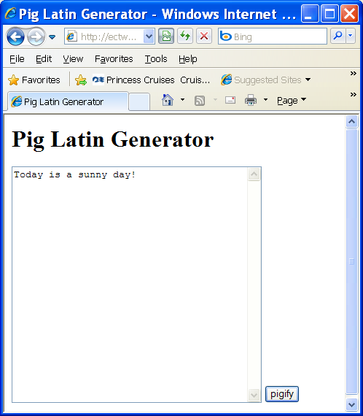  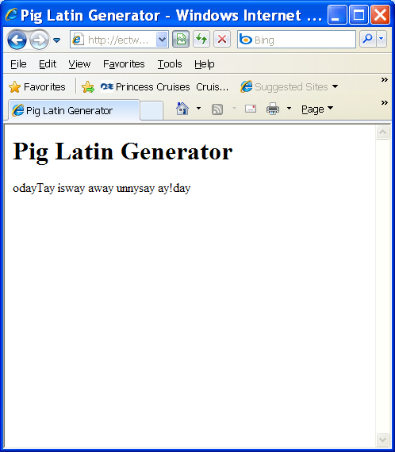 | Basics/plg.php  <html>  <head>  <title>Pig Latin Generator</title>  </head>  <body>  <h1>Pig Latin Generator</h1>  <?php  if (!filter_has_var(INPUT_POST, "inputString")){  print <<<HERE  <form action = ""  method = "post">  <textarea name = "inputString"  rows = "20"  cols = "40"></textarea>  <input type = "submit"  value = "pigify" />  </form>  HERE;  } else {  //there is a value, so we'll deal with it  $inputString = filter_input(INPUT_POST, "inputString");  $newPhrase = "";  //break phrase into array  $words = split(" ", $inputString);  foreach ($words as $theWord){  $theWord = rtrim($theWord);  $firstLetter = substr($theWord, 0, 1);  $restOfWord = substr($theWord, 1, strlen($theWord)-1);  //print "$firstLetter) $restOfWord <br /> \n";  if (strstr("aeiouAEIOU", $firstLetter)){  //it's a vowel  $newWord = $theWord . "way";  } else {  //it's a consonant  $newWord = $restOfWord . $firstLetter . "ay";  } // end if  $newPhrase = $newPhrase . $newWord . " ";  } // end foreach  print "<p>$newPhrase</p> \n";  } // end if  ?>  </body>  </html>

